Paul Polsinelli

IFT 220 – 90917a

8/26/20

Lab 1

1. With Hyper-V open, click the Action tab on the top left, then hover over New, then select and click Virtual Machine

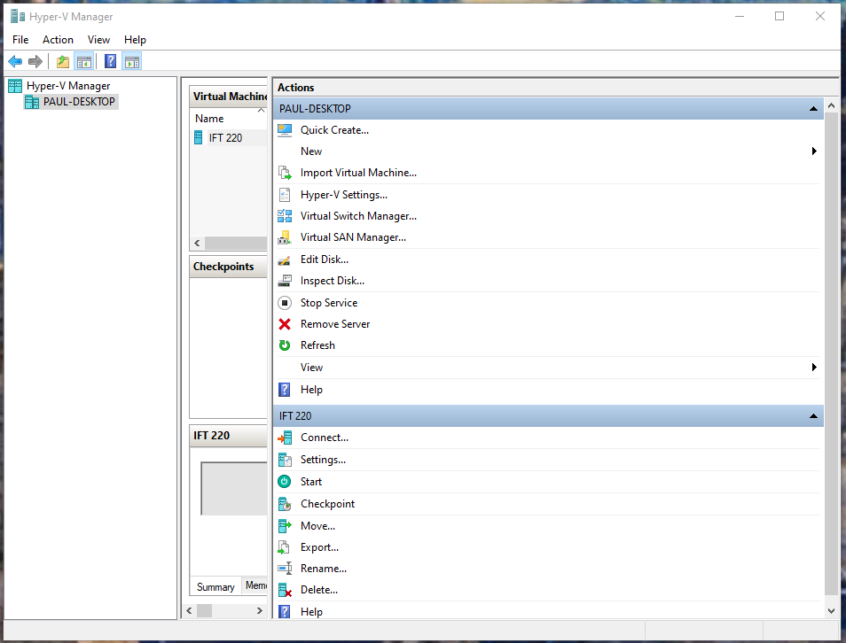

1. Click Next

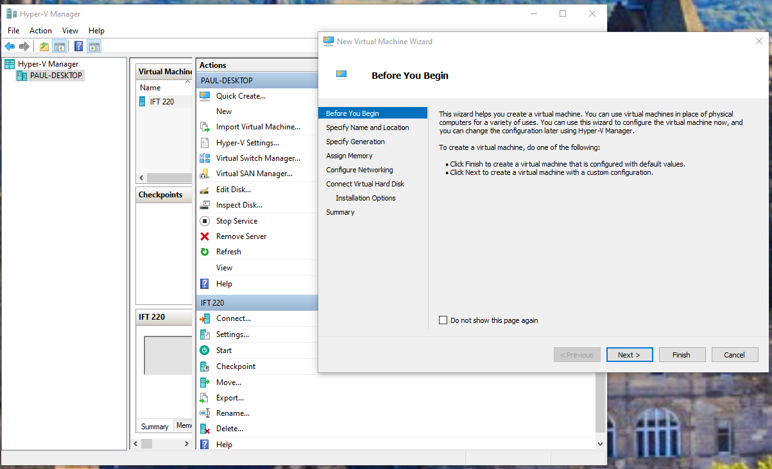

1. Choose your name and directory preferences. Click Next.

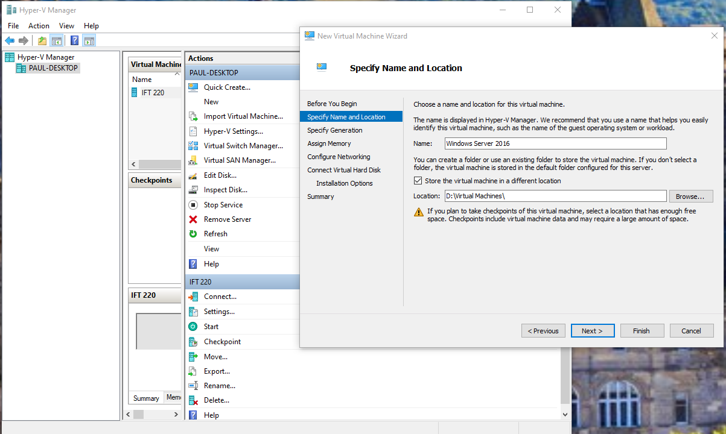

1. Specify which generation you which to use. I chose Gen 2 to take advantage of newer features. Click Next.

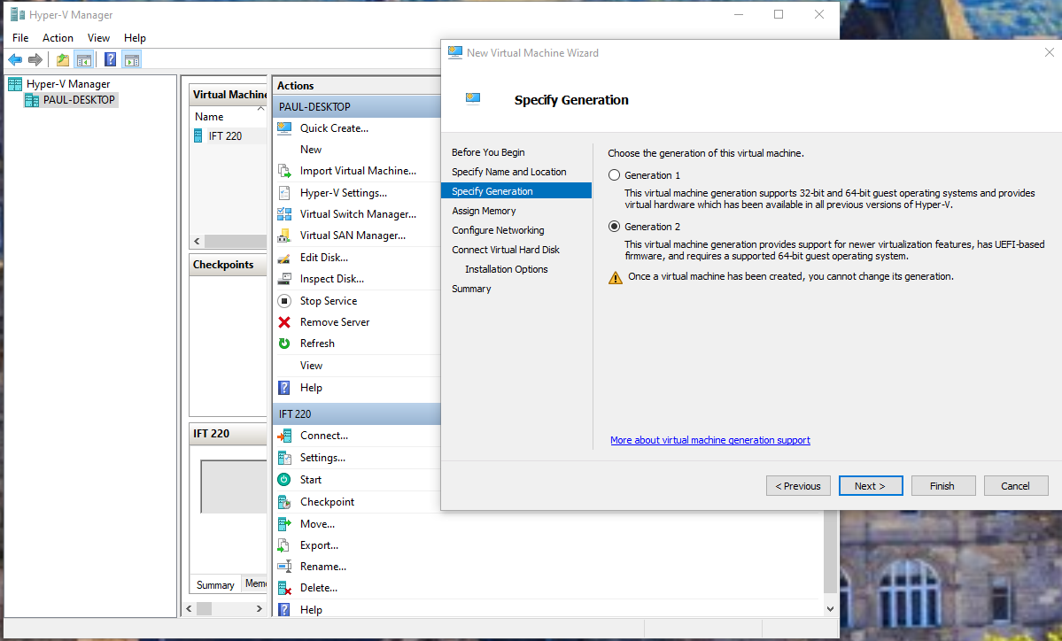

1. Assign Memory for Windows Server. I chose the default 1024 because it is double what Windows Server 2019 requires at a minimum and the Microsoft site advises allocating more than the minimum 512 MB required. I also chose Dynamic Memory in case it needs to scale up during a specific operation. Click Next.

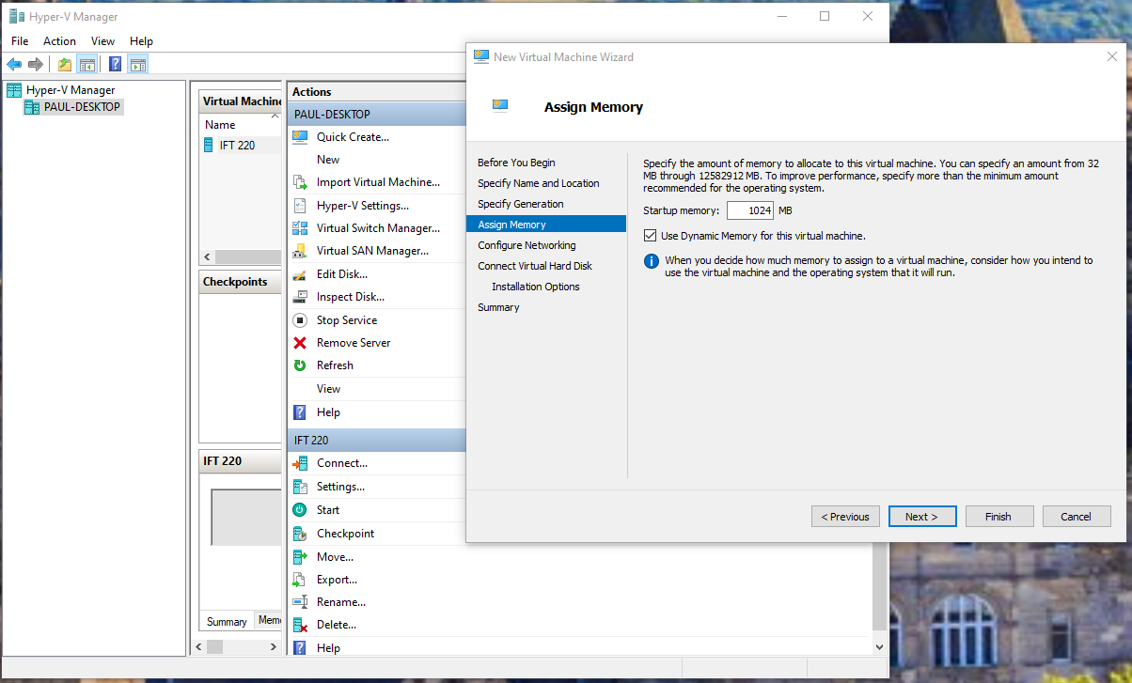

1. Choose your network adapter. I chose the default as the only other choice was Not Connected. Click Next.

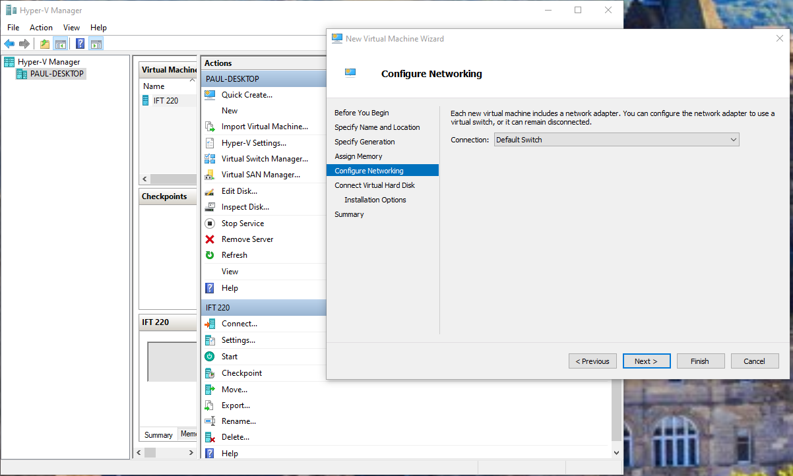

1. Connect a virtual hard disk by choosing to create one or use and existing one. I kept the default size because the absolute minimum recommended for Windows Server 2019 is 32 GB and I have plenty of space. Click Next.

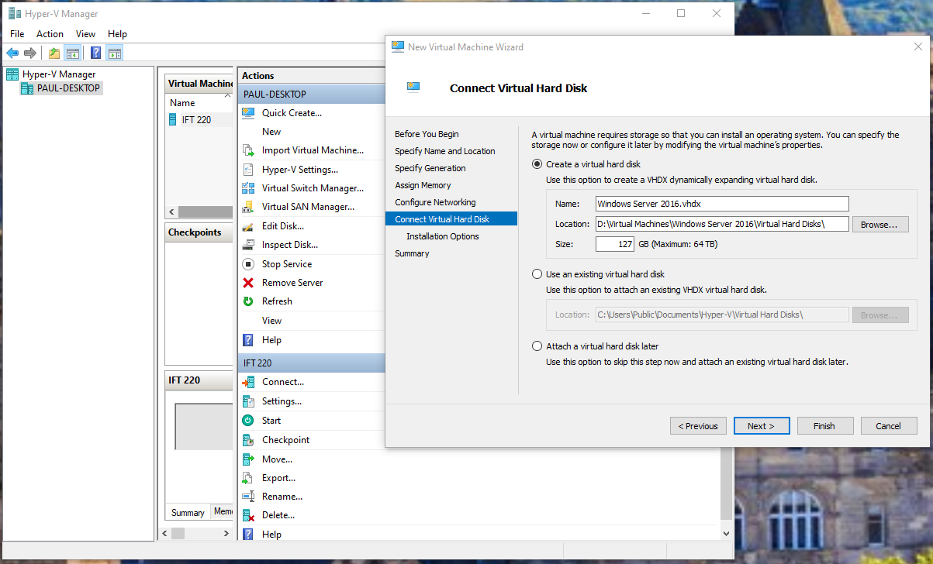

1. Choose method of installation and file. Click Next.

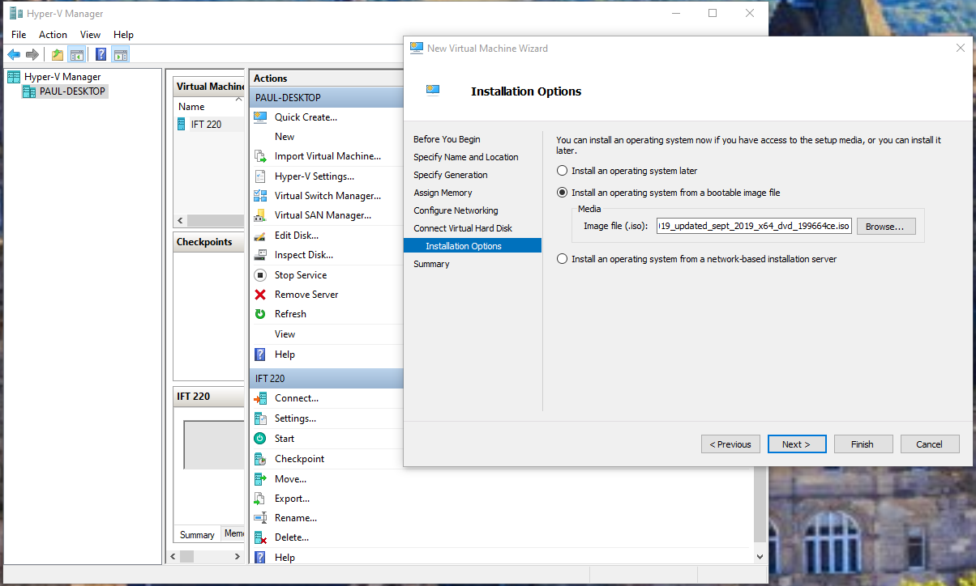

1. Click Finish.

